
SHIRE HIGHLANDS EDUCATION DIVISION
2026 MALAWI SCHOOL CERTIFICATE OF EDUCATION MOCK
EXAMINATION

CHEMISTRY
Subject Number: M038/II
Friday, 27 March Time Allowed: 2 hour Sessions
10:00 am onwards

PAPER II
PRACTICAL
(40 MARKS)

ISTRUCTIONS
Question number | Tick if answered | Do not write in these columns
1
2
3

4
- This paper contains 6 printed pages
Please check.
- Write your name and name of your school at
the top of each page.
- Answer all the four questions in the spaces
provided.
- Use of scientific calculators is allowed.
- The maximum number of marks for each answer
is indicated against each question.
- In the table provided on this page, tick against
the question number you have answered.
- Hand in your paper to the invigilator when time
is called to stop writing.

Turn over
Section A (20 marks)
Answer all the two questions in this section in the spaces provided.
- Describe an experiment that can be conducted to determine the concentration of a salt solution using evaporation method.
__________________________________________________________________________________________________________________________________________________________________________________________________________________________________________________________________________________________________________________________________________________________________________________________________________________________________________________________________________________________________________________________________________________________________________________________________________________________________________________________________________________________________________________________________________________________________________________________________________________________________________________________________________________________________________________________________________________________________________________________________________________________________________________________________________________________________________________________________________________________________________________________________________________________________________________________________________________________________________________________________________________________________________________________________________________________________________________________________________________________________________________________________________________________________________________________________________________________________________________________________________________________________________________________________________
(10 marks)
- Describe an experiment that could be conducted to distinguish an alkanal from an alkanone using Fehling’s test.
_________________________________________________________________________________________________________________________________________________________________________________________________________________________________________________________________________________________________________________________________________________________________________________________________________________________________________________________________________________________________________________________________________________________________________________________________________________________________________________________________________________________________________________________________________________________________________________________________________________________________________________________________________________________________________________________________________________________________________________________________________________________________________________________________________________________________________________________________________________________________________________________________________________________________________________________________________________________________________________________________________________________________________________________________________________________________________________________________________________________________________________________________________________________________________________________________________________________________________________________________________________________________________________________________________________________________________________________________________________________________________________________________________________
(10 marks)
SECTION B (20 Marks)
- You are provided with 3 test tubes in a rack, distilled water in a wash bottle, magnesium sulphate (MgSO₄) solution, copper sulphate (CuSO₄) solution, iron sulphate (FeSO₄) solution, 3 pieces magnesium metal, 3 pieces of copper metal, 3 iron nails and a measuring cylinder.
- Measure 5ml of magnesium sulphate solution and pour it in each of the 3 test tubes.
- Place a piece of magnesium metal, copper metal and iron nail in each test tube.
- Observe and record the results by indicating reaction and no reaction in the appropriate spaces in Table 1.
- Rinse the test tubes with distilled water.
- Repeat steps a to d using copper sulphate and iron sulphate solutions.
Table 1
Solution  Metal | Magnesium sulphate solution | Copper Sulphate solution | Iron Sulphate solution
Magnesium
Copper
Iron
(6 marks)
- Arrange the metals in order of their reactivity, with the most reactive metal at the top.

(3 marks)
- Which of the metals is the strongest reducing agent?

_________________________________________________________________
(1mark)

- You are provided with copper sulphate (CuSO₄) solution, a beaker, a copper metal strip, 2 cells in a holder, 3 connecting wires with crocodile clips, a switch and an iron nail.
- Arrange the apparatus as shown in Figure 1
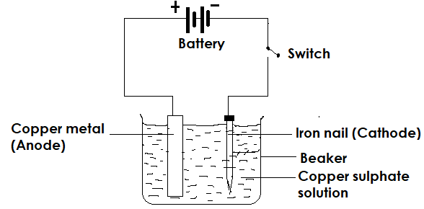
Figure 1
- Note and record the initial colours of copper metal and iron nail
- Close the switch and let current flow for 5 minutes
- Remove the electrodes from the copper sulphate solution
- Record your observations in Table 2
Table 2
Electrode | Initial colour | Final colour
Copper metal
Iron nail
(4marks)
- Using appropriate half equations at the anode and cathode, explain the observation on the iron nail.
__________________________________________________________________________________________________________________________________________________________________________________________________________________________________________________________________________________________________________________________________________________________________________________________________________________________________________________________________________________________________________
(6 marks)
END OF QUESTION PAPER

